Lecture 3
Introduction to business rules
Every company follows rules, laws, and industry standards to run smoothly. These guiding principles are called business rules or business logic. Business rules usually come from outside the software, like legal regulations or company policies. People often mix up business rules with business processes (how work gets done) or business requirements (what a system or project needs).
- Company policies (what the business wants to do)
- Legal rules (what the government requires)
- Industry standards (what is common practice)
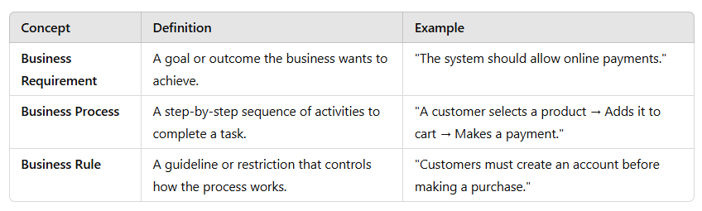
Business rule taxonomy
Business perspective: A business rule is a guideline for how people should work.
- Example: "A customer must be at least 18 years old to open a bank account."
- This rule is made by the business to control how things should be done.
System perspective: A business rule is a rule that the software follows to make sure the business works correctly.
- Example: "The online form will not let a user enter an age below 18 when opening an account."
- The system follows this rule to make sure no one breaks the business rule.
The business makes the rules, and the system helps apply them!

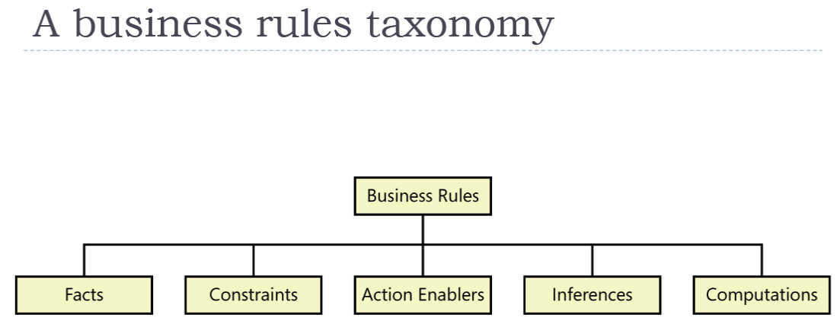
Facts
Facts are true statements about a business at a given time. They describe relationships between important business terms (Product & Bar Code). Facts help define how a business operates, and systems use these facts to ensure rules are followed.
Examples:
- Retail Business: "Every product in the store has a unique barcode."
- E-commerce: "Every order includes a shipping charge."
- Tax Rules: "Sales tax is not applied to shipping costs."
Constraints
A constraint is a rule that limits or restricts what users or the system can do. It ensures that actions follow business policies. A constraint prevents or allows only specific actions. It may also restrict who can perform an action.
Example
- Banking: "A customer must not withdraw more than their account balance." (Limits withdrawal amounts.)
- Employee Access: "Only HR staff can view employee salary details." (Limits access based on roles.)
1. Organizational Policies (Company Rules)
These are rules set by a business or organization.
- Loans: "If you are under 18, you need a parent or guardian to co-sign your loan."
- Library: "You can only have 10 books on hold at a time."
2. Government Regulations (Legal Rules)
These are laws that businesses must follow.
- Accessibility: "Software must be designed so visually impaired people can use it."
- Pilot Rest Time: "Pilots must have at least 8 hours of rest in a 24-hour period."
3. Industry Standards (Rules Set by Experts)
These are guidelines made by professionals in a specific industry.
- Home Loans: "People applying for a mortgage must meet Federal Housing Authority rules."
- Web Development: "Websites should not use outdated HTML code that is no longer allowed in HTML5."
Action Enabler
An action enabler is a rule that triggers an activity when certain conditions are met. This action can either be done manually by a person or automatically by software.
Example:
For example, in a company, there might be a rule that says, "If an employee is late three times, the manager must give a warning." Here, the manager takes action based on the rule. On the other hand, in an online store, a system can have a rule like, "If a payment is overdue by 30 days, send a reminder email." In this case, the software automatically sends the email when it detects the overdue payment.
Inferences
An inference is a new fact that is created based on existing facts. It is sometimes called inferred knowledge or a derived fact because it is not directly stated but logically follows from what is already known.
Inferences often follow an "if/then" pattern, similar to action enablers. However, the key difference is that inferences provide new knowledge, while action enablers trigger an action.
Example:
- Fact 1: "All employees with over 5 years of experience are eligible for a promotion."
- Fact 2: "John has 6 years of experience."
- Inference: "John is eligible for a promotion."
No action is taken here; it is simply a logical conclusion based on the facts provided
Computations
Computations are rules that use mathematical formulas or algorithms to create new data from existing data. These rules help businesses calculate important values automatically.
Some computations are based on external rules, like government tax formulas, while others are specific to a company.
Example 1 (Salary Calculation):
- Fact 1: "An employee earns $20 per hour."
- Fact 2: "The employee worked 40 hours."
- Computation: "Total salary = 20 × 40 = $800."
Example 2 (Tax Withholding):
- Fact 1: "The government requires 10% tax on salaries."
- Fact 2: "A person’s salary is $5000."
- Computation: "Tax = 10% of 5000 = $500."

Atomic Business Rule
An atomic business rule is a small, clear, and specific rule that answers a direct question. It is called "atomic" because it cannot be broken down further while still making sense.
Example:
Question: "What is the late fee for returning a library book?"
Rule: "The late fee for a library book is $0.50 per day, up to a maximum of $10."
This rule is atomic because:
- It gives a clear and complete answer.
- It does not need to be broken down further to make sense.
- It sets specific conditions (fee per day and maximum limit)
